**1.PROBLEM**

**CSS - Links**

"Silver Star Events" provides a full fledged event management service for all sorts of personalized and social events. Harry Stock, the proprietor of the company reviews the status of the events organized by the company in their official webpage. While reviewing through the events, he felt that the event category buttons listed in the page can be enabled when a user hovers the mouse over them. Once by clicking the buttons, it should display the corresponding event details.  
Harry quickly called upon you to implement this requirement. Create a web page which contains the button styled with CSS properties on Hovering.

**Hints :**

**:hover selector**

The :hover selector is used to select elements when you mouse over them.

Syntax :

:hover {

css declarations;

}

**Content :**  
h1 - Event Schedule  
First **'a'** tag - Wedding Events  
class - '**anchor1'**  
href - **'Wedding.html'**  
  
Apply the following style property to an 'a' tag with class 'anchor1'  
background-color - **'white'**  
border - **'2px solid #42f4ce'**  
border-radius - **'5px'**  
color - **'black'**  
padding - **'10px'**  
text-decoration - **'none'**  
  
Apply the following hover property to an **'**a' tag with class 'anchor1'  
background-color - **'#42f4ce'**  
color - **'white'**  
  
Second **'a'** tag - Corporate Events  
class - '**anchor2'**  
href - **'Corporate.html'**  
  
Apply the following  style property to an 'a' tag with class 'anchor2'  
background-color- **'white'**  
border - **'2px solid #b0f0f2'**  
border - radius - **'5px'**  
color - **'black'**  
padding - **'10px'**  
text-decoration - **'none'**  
  
Apply the fiollowing hover property to an 'a' tag with class 'anchor2'  
background-color - **'#b0f0f2'**  
color - **'white'**  
  
Third **'a'** tag - SocialGatherings  
class - **'anchor3'**  
href - **'SocialGatherings.html'**  
  
Apply the following  style property to an 'a' tag with class 'anchor3'  
background-color -**'white'**  
border - **'2px solid #ead2f2'**  
border-radius - **'5px'**  
color- **'black'**  
padding - **'10px'**  
text-decoration - **'none'**  
  
Apply the following hover property to an 'a' tag with class 'anchor3'  
background-color - **'#ead2f2'**  
color - **'white'**  
  
  
**Constraints :**  
The count of **'a'** tag must be 3.  
Apply the style properties specified in the content.  
Constraints including the class attribute should be as same as given in the content.  
  
**Note :**  
Web page should be displayed as shown in the screenshot.  
Kindly refer the content which is given as a part of the description  
  
**Sample Screenshot 1:**  
  
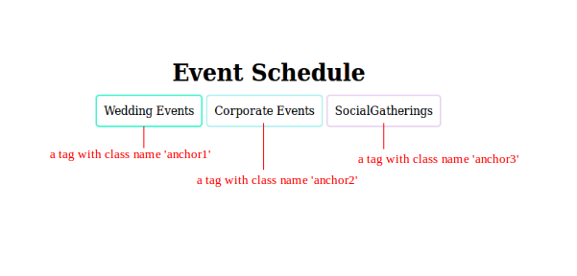  
  
**Sample Screenshot 2:**  
  
